EXPT NO:5 | DASHBOARD DESIGNING
DATE: 24.01.2026 | DASHBOARD DESIGNING

PRE-LAB QUESTIONS
- How do dashboards support strategic decision-making?
Dashboards support strategic decision-making by summarizing key data into actionable insights. They help leaders quickly understand trends, compare performance across departments, detect issues early, and make data-driven decisions instead of relying on assumptions.

- What role do dashboards play in AI monitoring systems?
In AI monitoring systems, dashboards act as a real-time control panel. They track important AI outputs such as predictions, alerts, performance metrics, and anomalies. This helps stakeholders monitor system health, verify results, and respond quickly when the AI system shows unusual patterns or errors.

- Why is interactivity essential in modern dashboards?
Interactivity is essential because users need to explore data dynamically. Features like filters, slicers, drill-down, and drill-through allow users to view insights by department, semester, or student level. This makes dashboards more useful for analysis and improves decision-making speed.

- What cognitive overload issues exist in dashboards?
Cognitive overload happens when dashboards show too much information at once, such as too many charts, colors, or numbers. This makes it hard for users to focus and understand insights quickly. A good dashboard avoids overload by using simple layouts, clear KPIs, and meaningful visuals.

- How are KPIs derived from raw data?
KPIs are derived by processing raw data using calculations and aggregation methods. For example:
- Attendance KPI = average attendance percentage
- Performance KPI = average internal marks / grade distribution
- Risk KPI = count of students below a threshold (like attendance < 75%)
These are created using formulas (like DAX in Power BI) to convert raw records into meaningful metrics.

OBJECTIVE: To design an interactive analytical dashboard for monitoring key metrics.
SCENARIO: An AI-based smart campus system requires a dashboard to monitor attendance, academic performance, and resource utilization in real time.
IN-LAB TASKS (Using PowerBI)

• Design KPI cards for attendance and performance
• Implement filters by department and semester
• Link multiple views for drill-down analysis

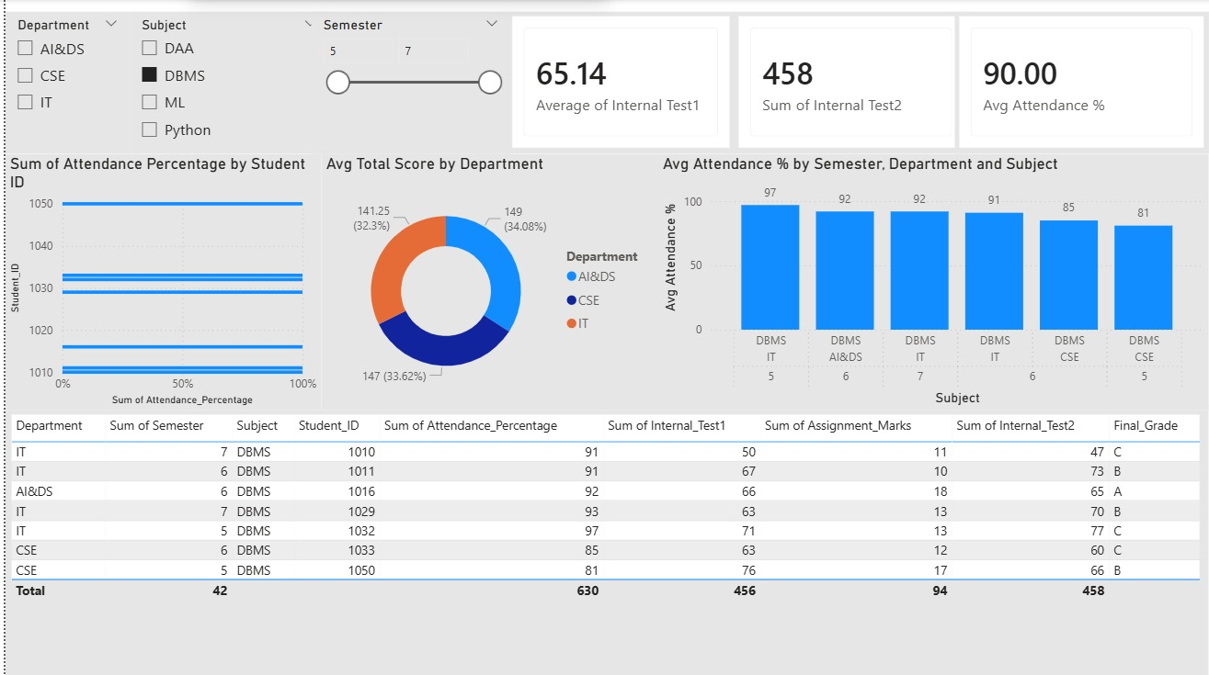

POST-LAB QUESTIONS
- How does interactivity improve analytical depth?
Interactivity improves analytical depth by allowing users to explore data at multiple levels. Using slicers, drill-down, and drill-through, users can move from a summary view (overall performance) to detailed insights (department → semester → subject → student), helping identify the root cause of trends.

- Which KPIs are critical for academic monitoring?
Key KPIs for academic monitoring include:
- Average Attendance %
- Students below attendance threshold (e.g., <75%)
- Average internal test scores
- Assignment performance
- Grade distribution (A/B/C/D)
These KPIs help track both participation and academic outcomes.

- What design principles prevent information overload?
Design principles that prevent overload are:
- Keep only essential KPIs
- Use a clean layout with sections
- Limit visuals (avoid too many charts)
- Use consistent colors and fonts
- Prefer simple charts over complex visuals
- Add filters and drill-down instead of showing everything at once
This makes dashboards easy to understand quickly.

- How can dashboards be integrated with AI alerts?
Dashboards can integrate AI alerts by showing:
- Real-time warning indicators (ex: “At-risk students increasing”)
- Threshold-based alerts (attendance < 75%, marks below cutoff)
- Notification panels for anomalies
AI models can generate predictions and alerts, and the dashboard displays them for fast action.

- How do dashboards enhance transparency in institutions?
Dashboards enhance transparency by providing clear, visual access to performance data for stakeholders like students, faculty, and management. They ensure decisions are based

LEARNING OUTCOME: Students understand dashboard design for AI-driven environments.
ASSESSMENT
Description | Max Marks | Marks Awarded
Pre Lab Exercise | 5
In Lab Exercise | 10
Post Lab Exercise | 5
Viva | 10
Total | 30
Faculty Signature

